# Docker Cheat Sheet

## Introduction

Containers allow the packaging of your application (and everything that you need to run it) in a "container image". Inside a container you can include a base operational-system, libraries, files and folders, environment variables, volumes mount-points, and the application binaries.

A "Docker image" is a template for the execution of a container --- It means that you can have multiple containers running from the same image, all sharing the same behavior, which promotes the scaling and distribution of the application. These images can be stored in a remote registry to ease the distribution.

Once a container is created, the execution is managed by the "Docker Engine" aka "Docker Daemon". You can interact with the the Docker Engine through the "docker" command. These three primary components of Docker (client, engine and registry) are diagramed below:

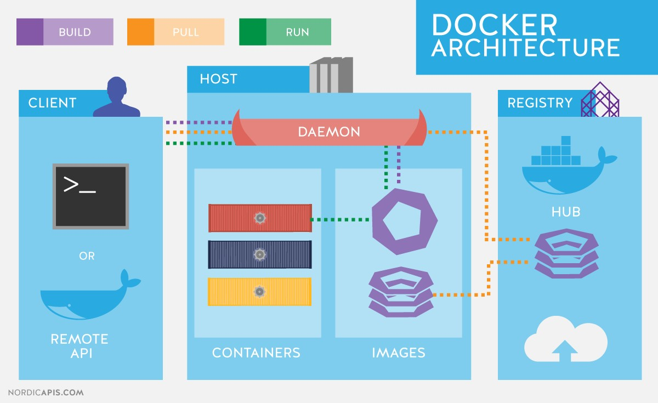

# Docker Engine

## Container related commands

docker [CMD] [OPTS] CONTAINER

Examples:

All examples provided here work in RHEL

1. Run a container in interactive mode:

$ docker run -it ubuntu /bin/bash # Run a bash shell inside an image

1. Run a container in detached mode:

$ docker run --name mywildfly -d -p 8080:8080 jboss/wildfly

1. Run a detached container in a previously created docker network:

$ docker network create mynetwork

$ docker run --name mywildfly-net -d --net mynetwork -p 8080:8080 jboss/wildfly

1. Run a detached container mounting a local folder inside the container:

$ docker run --name mywildfly-volume -d \

-v myfolder/:/opt/jboss/wildfly/standalone/deployments/ \

-p 8080:8080 jboss/wildfly

1. Follow the logs of a specific container

$ docker logs -f mywildfly $ docker logs -f <container-name>

1. List containers

$ docker ps # List only active containers $ docker ps -a # List all containers

1. Stop a container

|  |  |
| --- | --- |
| $ docker stop <container-name> | # Stop a container |
| $ docker stop -t 1 <container-name> | # Stop a container (timeout = 1 second) |

1. Remove a container

$ docker rm <container-name> # Remove a stopped container

$ docker rm -f <container-name> # Remove a stopped container. Force stop if it is active

$ docker rm -f $(docker ps -aq) # Remove all containers

$ docker rm $(docker ps -q -f "status=exited”) # Remove all stopped containers

1. Execute a new process in an existing container

$ docker exec -it mywildfly /bin/bash # Executes and access bash inside a WildFly container

|  |  |
| --- | --- |
| attach | Attach a running container to view its ongoing output or to control it interactively |
| commit | Create a new image from a container’s changes |
| cp | Copy files/folders between a container and the local filesystem |
| create | Create a new container |
| diff | Inspect changes on a container’s filesystem |
| exec | Run a command in a running container |
| export | Export the contents of a container’s filesystem as a ‘.tar’ archive |
| kill | Kill a running container using SIGKILL or a specified signal |
| logs | Fetch the logs of a container |
| pause | Pause all processes within a container |
| port | List port-mappings, or lookup the public-facing port that is NAT-ed to the  PRIVATE_PORT |
| ps | List all containers |
| rename | Rename a container |
| restart | Restart a container |
| rm | Remove/delete one or more containers |
| run | Run a command in a new container |
| start | Start one or more containers |
| stop | Stop a container by sending SIGTERM then SIGKILL after a grace period. |

## Image related commands

docker [CMD] [OPTS] IMAGE

### Examples

1. Build an image using a Dockerfile

$ docker build -t [username/]<image-name>[:tag] <dockerfile-path> # Build an image $ docker build -t myimage:latest . # Build an image called myimage using the Dockerfile in the same folder where the command was executed.

1. Check the history of an image

$ docker history jboss/wildfly #Check the history of the jboss/wildfly image $ docker history [username/]<image-name>[:tag] # Check the history of an image

1. List the images

$ docker images

1. Remove an image from the local registry

$ docker rmi [username/]<image-name>[:tag]

1. Tag an image

$ docker tag jboss/wildfly myimage:v1 # Creates an image called

"myimage" with the tag "v1" for the image jboss/wildfly:latest

$ docker tag <image-name> <new-image-name> # Creates a new image with the latest tag

$ docker tag <image-name>[:tag] [username/]<new-image-name>[:new-tag] # Creates a new image specifying the "new tag" from an existing image and tag.

1. Exporting and Importing and image to an external file

$ docker save -o <filename>.tar [username/]<image-name>[:tag] # Export the image to an external file

$ docker load -i <filename>.tar # Import an image from an external file

1. Push an image to a registry.

$ docker push [registry/][username/]<image-name>[:tag]

|  |  |
| --- | --- |
| build | Build Docker images from a Dockerfile |
| history | Show the history of an image |
| images | List images |
| import | Create an empty filesystem image and import the contents of the tarball into it |
| inspect | Return low-level information on a container or image |
| load | Load an image from a ‘.tar’ archive or STDIN |
| pull | Pull an image or a repository from the registry |
| push | Push an image or a repository to the registry |
| rmi | Remove one or more images |
| save | Save one or more images to a ‘.tar’ archive (streamed to STDOUT by default) |
| search | Search the Docker registry for images |
| tag | Tag an image into a repository |

## Network related commands

docker network [CMD] [OPTS]

|  |  |
| --- | --- |
| connect | Connects a container to a network |
| create | Creates a new network with the specified name |
| disconnect | Disconnects a container from a network |
| inspect | Displays detailed information about on a network |
| ls | Lists all the networks created by the user |
| rm | Deletes one or more networks |

## Registry related commands

Default is <https://index.docker.io/v1/>

|  |  |
| --- | --- |
| login | Log in to a Docker registry server. If no server is specified, then the default is used |
| logout | Log out from a Docker registry server. If no server is specified then the default is used. |

## Volume related commands

docker volume [CMD] [OPTS]

|  |  |
| --- | --- |
| create | Create a volume |
| inspect | Return low-level information on a volume |
| ls | List volumes |
| rm | Remove a volume |

# Dockerfile

The Dockerfile provides the instructions to build a container image through the `docker build -t [username/]<image-name>[:tag] <dockerfile-path>` command. It starts from a previous existing Base image (through the FROM clause) followed by any other needed Dockerfile instructions.

This process is very similar to a compilation of a source code into a binary output, but in this case the output of the Dockerfile will be a container image.

## Example Dockerfile

|  |
| --- |
| # Use the existing WildFly image FROM jboss/wildfly    # Add an administrative user  RUN /opt/jboss/wildfly/bin/add-user.sh admin Admin#70365 --silent    #Expose the Administrative port EXPOSE 8080 9990    # Bind the WildFly management to all IP addresses  CMD ["/opt/jboss/wildfly/bin/standalone.sh", "-b", "0.0.0.0", "-bmanagement", "0.0.0.0"] |

Using the example Dockerfile

|  |
| --- |
| # Build the WildFly image $ docker build -t mywildfly .    # Run a WidFly server  $ docker run -it -p 8080:8080 -p 9990:9990 mywildfly    # Access the WildFly administrative console and log in with the credentials admin/Admin#70365 open http://<docker-daemon-ip>:9990 in a browser |

Dockerfile INSTRUCTION arguments

|  |  |
| --- | --- |
| FROM | *Base Image* |
| MAINTAINER | Sets the author field of the the generated images |
| RUN | Executes commands in a new layer on top of the current image and commits the results |
| CMD | Allowed only once (if many, then only the last one takes effect) |
| LABEL | Adds metadata to an image |
| EXPOSE | Informs Docker that the container listens on the specified network ports at runtime. |
| ENV | Sets an environment variable |
| ADD | Copies new files, directories or remote file URLs into the filesystem of the container |
| COPY | Copies new files or directories into the filesystem of the container |
| ENTRYPOINT | Allows you to configure a container that will run as an executable |
| VOLUME | Creates a mount point and marks it as holding externally mounted volumes from native host or other containers |
| USER | Sets the user name or UID to use when running an image |
| WORKDIR | Sets the working directory for any RUN, CMD, ENTRYPOINT, COPY, and ADD commands |
| ARG | Defines a variable that users can pass at build-time to the builder using --build-arg |
| ONBUILD | Adds an instruction to be executed later, when the image is used as the base for another build |